Student ID: C00132795
Student Name: Shengjie Yuan
Supervisor: Christophe Meudec
Date of submission: 19.12.2010

< Another Bugs Contraption Detector>

Project Plan

Contents
Plan Introduction 1
Project Description 1
Project Plan Gantt Chart 2
Plan Conclusion……………………………………………………………………………………………………………………………6

Plan Introduction
This documentation is making a plan for project Another Bugs Contraption Detector. This is almost four months duration plan. The main goal of this project is implementing program and succeed test user`s target code, finish core function building. The main task of this plan is the following parts:
- Project design
- Project implementation
- Project testing

Project Description
The use area of this Bugs Contraption Detector is about software testing, and the Code Parsing, Code Instrumentation technologies would be used. This project allows automatic test inputs generation, it tries to generate input automatically. The ability to instrument, for test inputs generation purposes, during normal execution, information that are sent to an external constraints solver for automatic test data generation. For the additional function, it will try to make the target programming language useful and/or find problems in real code.

This project would be dividing into 3 versions as the following description:
- Version 1: in this version, the most base functions should able to work, it include target code path input, target code test, test result. In the test part, program can test and work out very simple code and algorithm, such as IF ELSE statement. In the first version, program should support data types include integer, double, charters and string. Those input types will be allowed. In the testing coverage criteria, it include simple assignment, IF ELSE and while();
- Version 2: in this version, I will improve the function of test target code, more complex code and algorithm should be able to executed, more output detail will display for user.
- Version 3: this is the final version of the program; I will try to design additional functions adding into this project. Improve functions, output result and correctness.
Each version of this program would be tested and debugged, and then go to next version develop, Confirm to minimize the error and bug is the base goals.

Project Plan Gantt chart
This project plan Gantt chart will cover form 29/11/2010 to the end of process of project.

29/11/2010～12/12/2010：
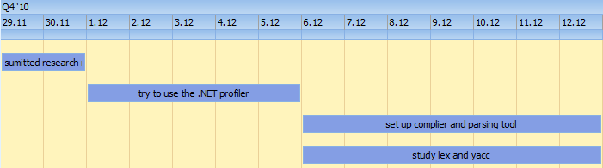

In this duration development, I tried to user the .NET profiler API, however it does not work with this project, so I decided to change use parsing tool instead, I set up the complier and parsing tool, try to study lex and yacc.

13/12/2010~31/12/2010:
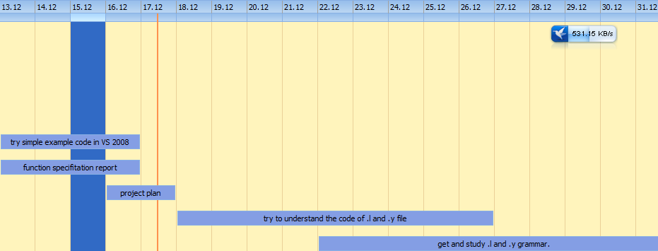

In this duration of development, function specification report has to submit on 16/12/2010. And then try simple example code in VS 2008, complete project plan. Try to understand the code of .l and .y file, get and study .l and .y grammar should be the main task.

1/1/2011～31/1/2011：
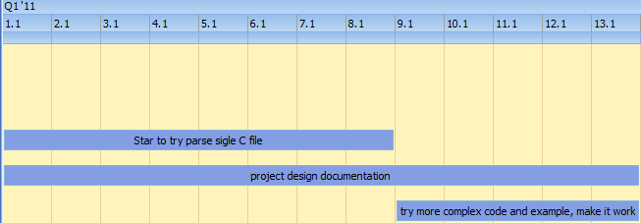
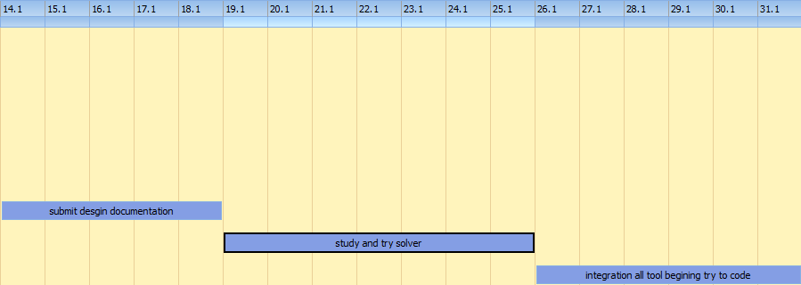

In this duration of development, project design documentation should be the main task, in this process, try parse single C file and try solver also are important task. Make sure all additional tool work successful and get ready for coding.

1/2/2011～5/3/2011：
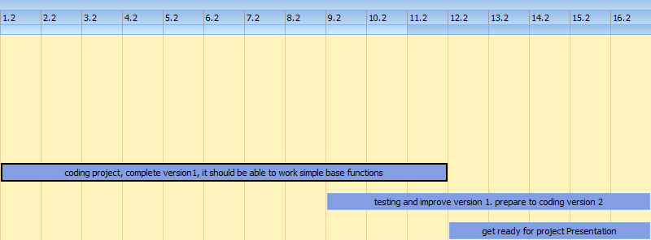

In this duration of development, beginning coding project, this project I try to develop to 3 versions, in the first version, it should be complete the very base functions and the simple code test. Testing and debugging version 1 also would include in this duration.

17/2/2011~5/3/2011:
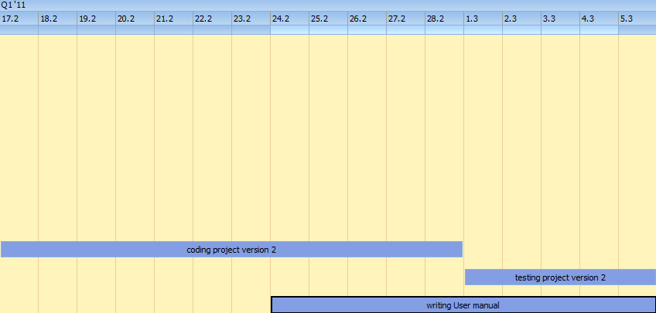

Version 2 of project will be coding in this development time, in this version, more complex functions would be complete. The User manual also begins to write. This manual has to hand up on 5/3/2011.

6/3/2011～28/3/2011：
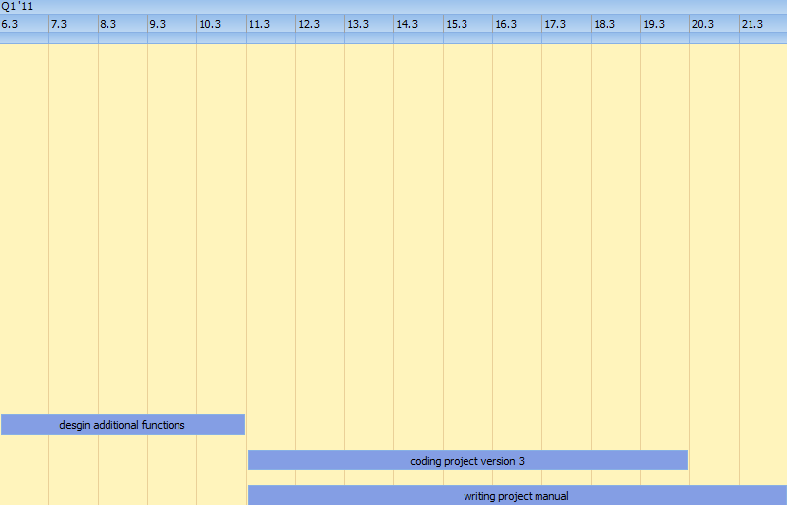

In this duration development, beginning to design additional functions, those functions should work and complete on version 3. And then star coding version 3 and begin writing project manual, this manual should be the last manual in this whole project. It should hand up on 21/3/2011.

22/3/2011~end of project
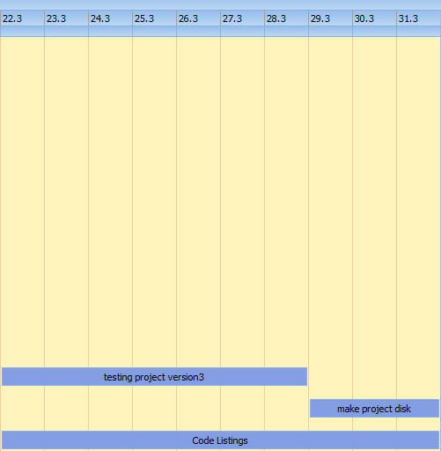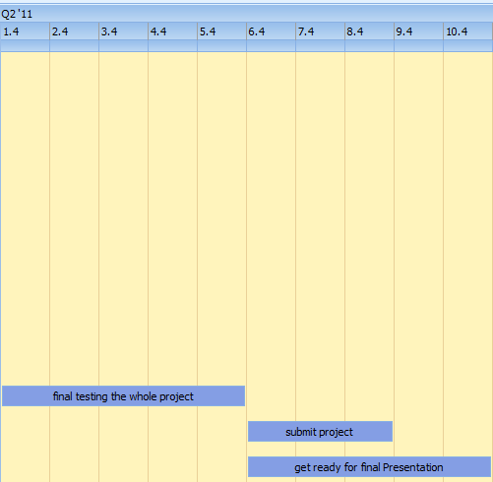

This should be end of duration development; version 3 should be testing and then writing code listings manual. The final testing of whole project also should be done, submit project and 8/4/2011, get ready for final presentation.

Plan Conclusion
This project plan to develop to three versions, the first version will be complete the very base functions, it should be can test simple code, such as if statement. And then the following version will improve on the base of version 1, it should be test more complex code and algorithm, the last version could be added some additional functions. During the development, program test will not stop; we will test and debugging every version to keep the minimum error.

The whole project must follow the following deadline time:
- Research Manual - Friday 26th November 2010
- Project Plan - Friday 19th Dec 2010
- Functional Specification - Friday 19th Dec 2010
- Design Manual - Monday 17th Jan 2011
- Project Presentation – Mid Feb 2011 (date to be confirmed)
- User Manual - Friday 8th April 2011
- Project Report - Friday 8th April 2011
- Code Listings - Friday 8th April 2011
- Project installation disks/CD - - Friday 8th April 2011
- Demo's will take place on Friday 15th April 2011

